**Project 3:**

**Even and Odd blinking of LED**

**Description**: In this project, we will show how leds are blinking in even state and then the leds blink whose are at odd state.

**Required Hardware:**

* Arduino Uno.
* Breadboard.
* Jumper wire.
* 6 LED
* Resistor.
* USB type A/B.

**LED**:

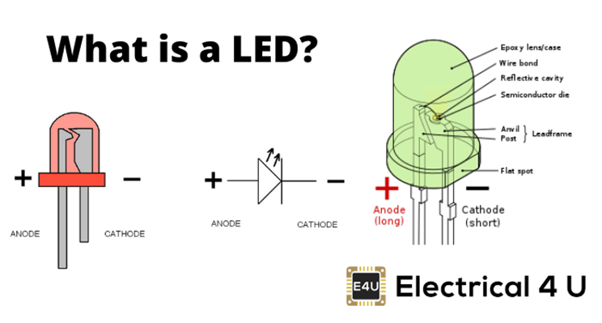

**PIN OF LED:**

* Led 1 Anode(+) to digital pin 5
* Led 2 Anode(+) to digital pin 6
* Led 3 Anode(+) to digital pin 7
* Led 4 Anode(+) to digital pin 8
* Led 5 Anode(+) to digital pin 9
* Led 6 Andoe(+) to digital pin 10

**Circuit Diagram:**

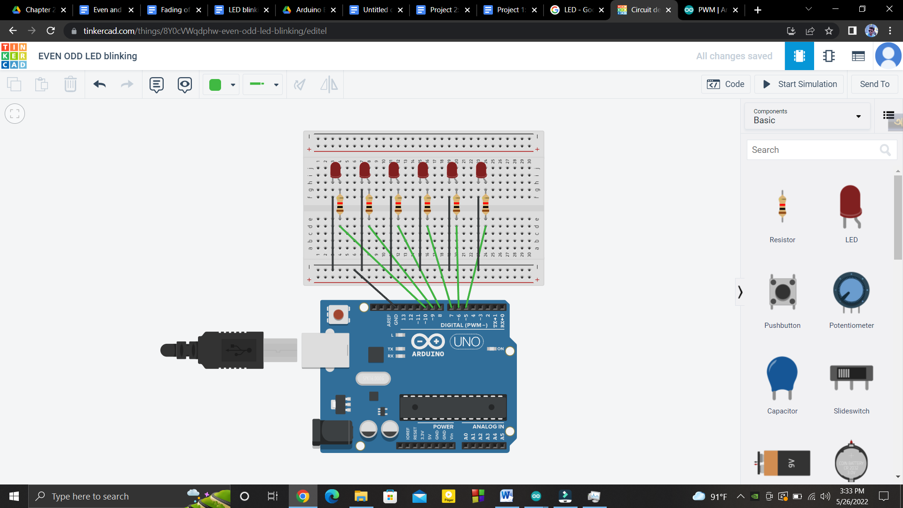

**Code:**

| int pin[]={5,6,7,8,9,10};  int i;  int dly=600;    void setup()  {  for(i=0;i<6;i++)  {    pinMode(pin[i], OUTPUT);  }  }  void loop()  {  for(i=0;i<6;i++)  {    if(i%2==0)  {  digitalWrite(pin[i], HIGH);  delay(dly);  digitalWrite(pin[i], LOW);  delay(dly);  }  }      for(i=0;i<6;i++)  {    if(i%2!=0)  {  digitalWrite(pin[i], HIGH);  delay(dly);  digitalWrite(pin[i], LOW);  delay(dly);  }  }      } |
| --- |